**11. Differential Phase Shift Keying (DPSK) Modulation and Demodulation**

**11.1 Objective**

To construct a DPSK modulation and demodulation system and interpret the modulated and demodulated waveforms in a communication kit based environment.

**11.2 Hardware Required**

1. DPSK Trainer Kit – ST8112
2. Dual Trace oscilloscope-POS-2020
3. Digital Multimeter

**11.3 Theory**

Differential phase shift keying is a non-coherent version of PSK. It eliminates the need for a coherent reference signal at the receiver by combining two basic operations at the transmitter:

1. Differential encoding of the input binary wave
2. Phase shift keying

In effect, to send symbol 0 we phase advance the current signal waveform by 180˚ , and to send symbol 1 we leave the phase of the current signal waveform unchanged. The DPSK transmitter consists of a logic network and a one-bit delay element interconnected so as to convert an input sequence {bk} into a differentially encoded sequence {dk}. This sequence is amplitude level shifted and then used to modulate a carrier wave of frequency fc, thereby producing the desired DPSK wave.

The received DPSK signal plus noise is passed through a band pass filter centered at the carrier frequency fc , so as to limit the noise power. The filter output and a delayed version of it, with the delay equal to the bit duration Tb, are applied to a correlator. The resulting correlator output is proportional to the cosine of the difference between the carrier phase angles in the two correlator inputs. The correlator output is finally compared with a threshold of zero volts, and a decision is thereby made in favor of symbol 1 or symbol 0. If the correlator output is positive, the phase difference between the waveforms received during the pertinent pair of bit intervals lies inside the range –Π/2 to Π/2, and the receiver decides in favor of symbol 1. If, on the other hand, the correlator output is negative, the phase difference lies outside the range –Π/2 to Π/2, modulo-2Π, and the receiver decides in favor of symbol 0.

**11.4 Wiring Diagram**

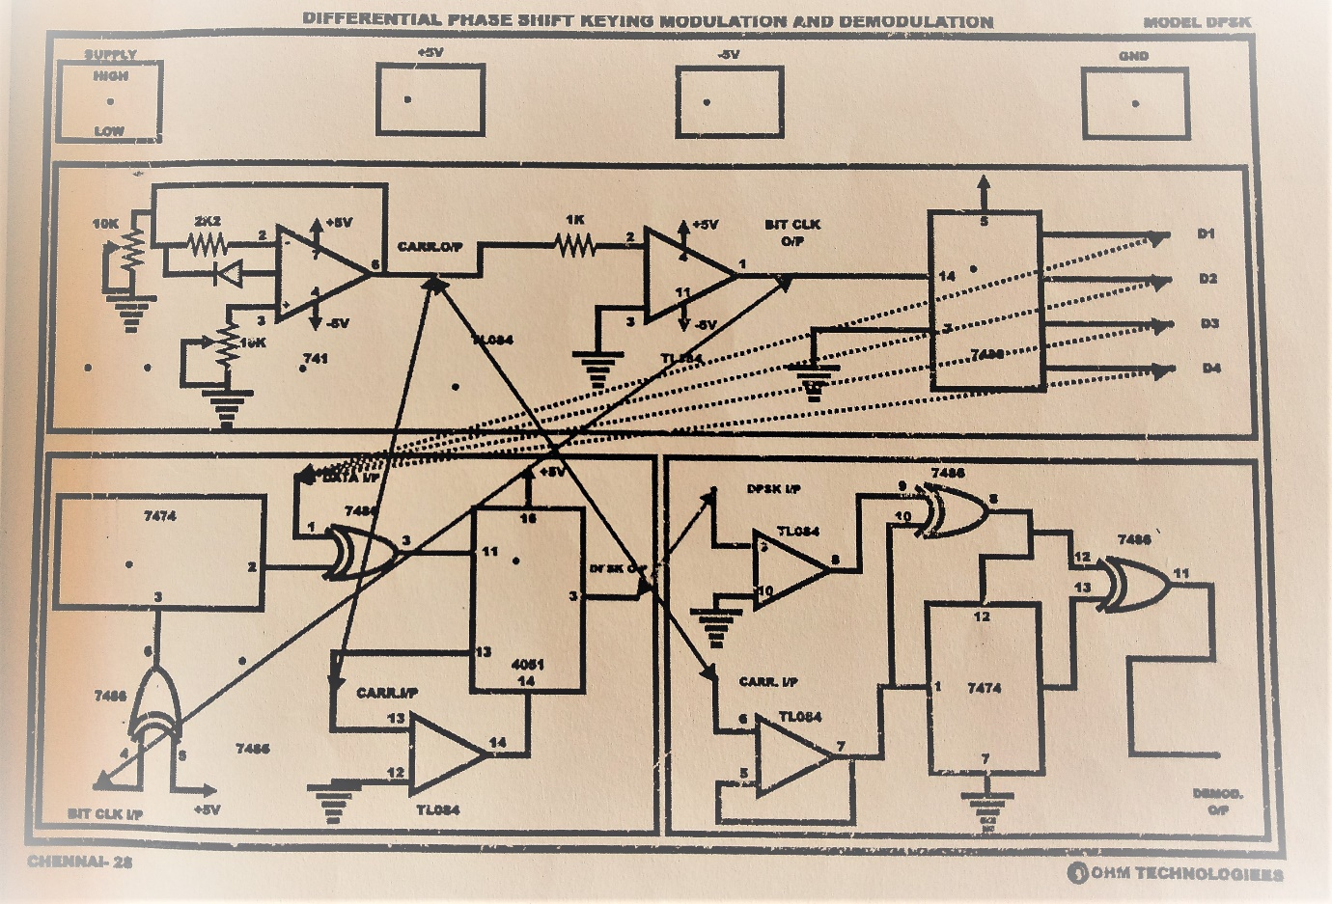

**Figure 11.1 Wiring diagram for DPSK Modulation and Demodulation**

**11.5 Procedure**

* + - 1. Connect the AC Supply to the Kit.
      2. Make connections and settings as shown in Block Diagram.
      3. Connect the carrier signal output from carrier block to the ‘Carrier Input’ post of PSK Modulator block. Connect the ‘D0’ from data block to the data input post of DPSK Modulator block.
      4. Switch ON the power.
      5. Connect the DPSK MOD O/P to the DPSK MOD I/P of DPSK demodulator section.

1. Connect the carrier signal output from carrier block to the ‘Carrier Input’ post of DPSK demodulator section.
2. Change the data I/P to D1, D2, D3 and observe the DPSK
3. O/P changes accordingly.
4. Observe the following waveforms on oscilloscope.
   1. Carrier signal O/P.
   2. Data O/P D0, D1, D2, D3.
   3. DPSK MOD O/P at DPSK Modulator.
   4. DPSK Demodulated signal at DPSK demodulator BLOCK.

**11.6 Model Graph**

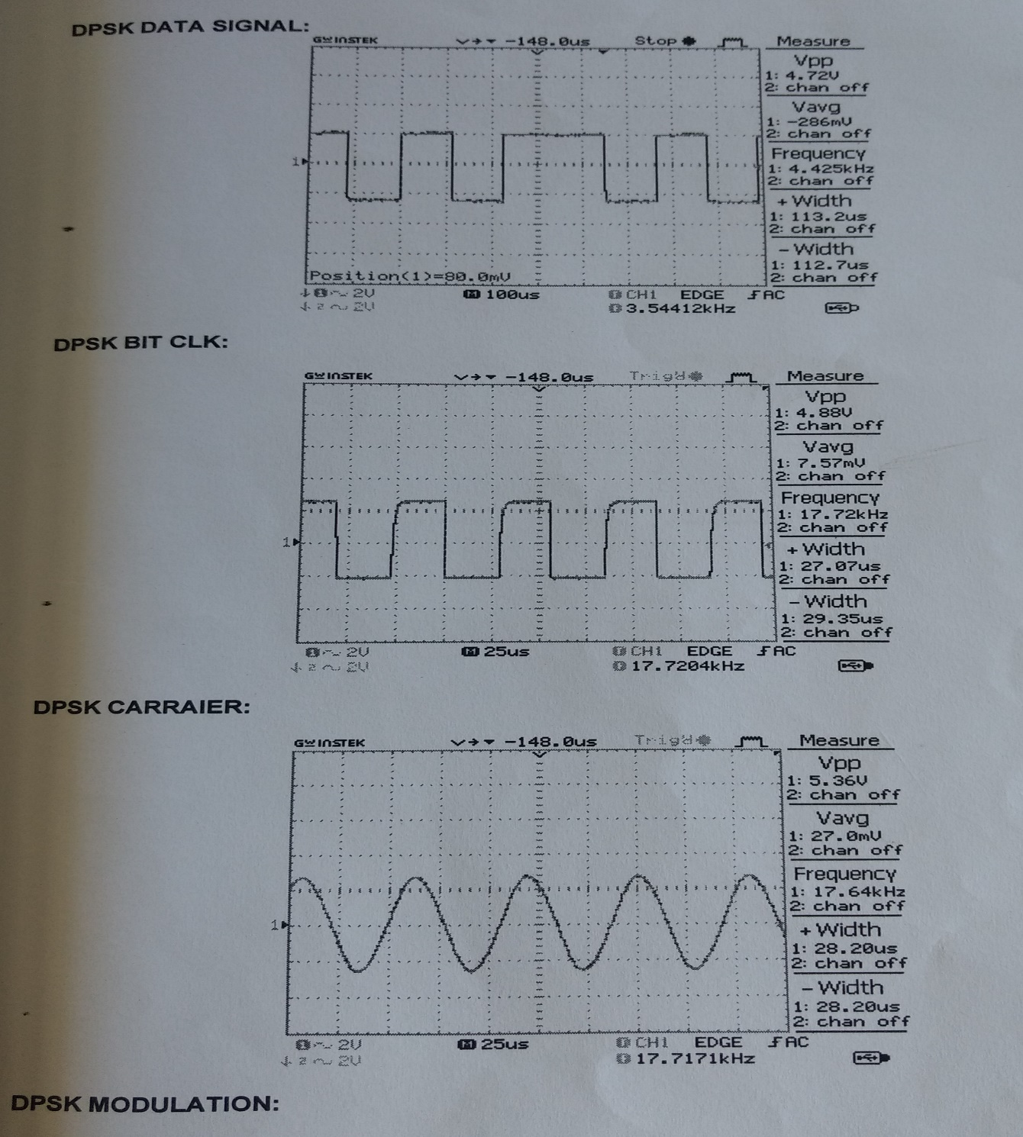

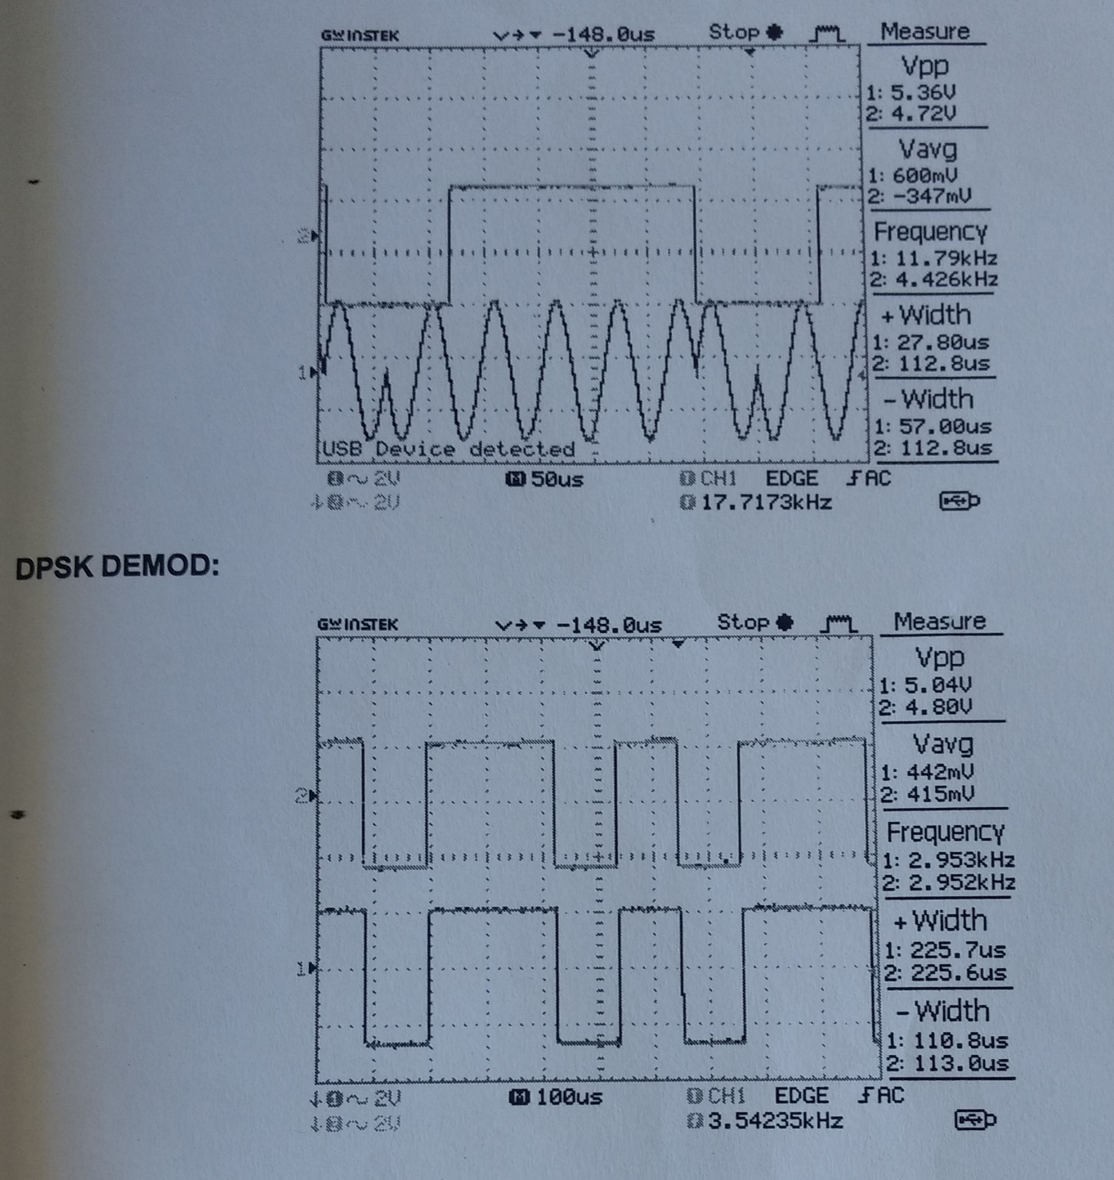

**11.2 Model Graph**

**11.7 Observation**

**DPSK (Modulation)**

|  |  |  |
| --- | --- | --- |
| **Data source** | **Amplitude (V)** | **Time Period (ms)** |
| D0 |  |  |
| D1 |  |  |
| D2 |  |  |
| D3 |  |  |
| **Carrier signal** |  |  |
| **Modulated output** |  |  |
| D0 |  |  |
| D1 |  |  |
| D2 |  |  |
| D3 |  |  |

**DPSK (Demodulation)**

|  |  |  |
| --- | --- | --- |
| **Demodulated output** | **Amplitude (V)** | **Time Period (ms)** |
| D0 |  |  |
| D1 |  |  |
| D2 |  |  |
| D3 |  |  |

**11.8 Pre-Lab Questions**

1. What are the merits of DPSK over PSK?
2. List the operations performed in DPSK transmitter.
3. What is differential encoding technique?

**11.9 Post Lab Questions**

1. Binary data is transmitted at a rate of 106 bits/second over a channel having a bandwidth 3 MHz Assume that the noise PSD at the receiver is N0/2 = 10-10 W/Hz. Find the average carrier power required at the receiver input for DPSK to maintain a probability of error Pe=10-4.
2. Compare DPSK and QPSK modulation scheme.

**11.10 Lab Result**

Thus, the DPSK modulation and demodulation using a communication kit has been conducted and necessary graphs were plotted.